Equipment list
This is a list of equipment that you need for your studies on Art and Technology. It is divided into three categories: must-have, should-have and nice-to-have. The items on the must-have list is required for you to follow the exercises and assignments on several semesters. The should-have and nice-to-have items are not required, but will make your life easier. Many of those items are also available in the labs, but most of them have to stay in the labs.
Regarding the must-have list: it is also possible to find kits that include both Arduino, breadboard, USB cable and a bunch of components, which can be helpful when you start to experiment with electronics.
Links are provided as an example. You are free to choose any supplier and manufacturer you want.
Indhold
Must-have:
Arduino Uno (R3)
Breadboard
AB USB Cable (printer cable) for Arduino
Multimeter
Should-have:
The following items can all be found in stores like Harald-Nyborg, Silvan, Bauhause (Harlad-Nybord is the cheapest option) Sticky-Tac / Blu-Tack / Elefantsnot
Diagonal cutter (DK: Skævbidder)
Plier (DK: Spidstang)
Screw driver set (both large and small)
Measuring tape (DK: Målebånd)
Jumper-wires
Nice-to-have
Wire stripper (for small wires)
Alligator clip test leads
Glue Gun
Utility Knife
Scissors
Cutting Ruler
Cutting Mat
Stores
Electronic stores:
Hardware stores:

See a more detailed list below.
If you have any questions you can ask them on the Moodle forum for ArT1: https://www.moodle.aau.dk/

Must-have:

Arduino Uno (R3)
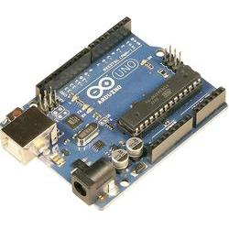
Try to avoid buying off brand and counterfeit Arduinos. Yes, they are cheaper, but some have problems that a bothersome to deal with as a beginner.
https://let-elektronik.com/arduino/11021-arduino-uno-r3.html

http://www.conradelektronik.dk/Arduino-Uno-Rev3-DIP-Version-Arduino-Arduino-Uno-Rev3-DIP-Version.htm?websale8=conrad-dk&pi=1275279&ci=SHOP_AREA_1013131_2420142
https://www.elextra.dk/main.aspx?page=article&artno=H31941

Breadboard
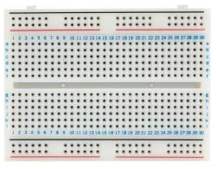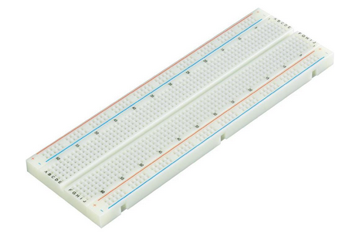
https://www.elextra.dk/main.aspx?page=article&artno=H39119

https://www.conradelektronik.dk/Printplade-EIC-102-Printplade.htm?websale8=conrad-dk&pi=526835&ci=SHOP_AREA_14742_2512070

AB USB Cable (printer cable) for Arduino
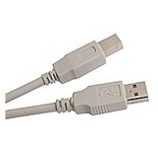
https://let-elektronik.com/byg-selv-kits/13921-usb-20-kabel-a-til-b-18-meter.html

https://www.elextra.dk/main.aspx?page=article&artno=H11509

https://www.conradelektronik.dk/USB-2%2e0-Tilslutningskabel-Digitus-%5b1x-USB-2%2e0-stik-A-1x-USB-2%2e0-stik-B%5d-0%2e50-m-Sort.htm?websale8=conrad-dk&pi=678048&ci=SHOP_AREA_258249_0410105

Multimeter
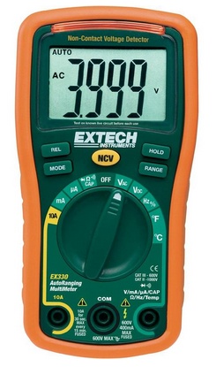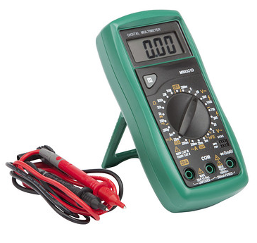
Large range of different price and quality. Make sure it can measure DCV, DCC, ACV, R, and has a buzzer/connectivity tester.
Good value:
http://www.harald-nyborg.dk/p7364/digital-multimeter-ms8321d

Good quality (with auto range):
https://www.conradelektronik.dk/H%e5nd-multimeter-digital-Extech-EX330-CAT-III-600-V-Visning-(counts):-4000.htm?websale8=conrad-dk&pi=122213&ci=SHOP_AREA_260570_1101010

Should-have:

The following items can all be found in stores like Harald-Nyborg, Silvan, Bauhaus (Harald-Nyborg is the cheapest option)
Sticky-Tac / Blu-Tack / Elefantsnot
Any book store (or Archi-Tegn at the Create building)
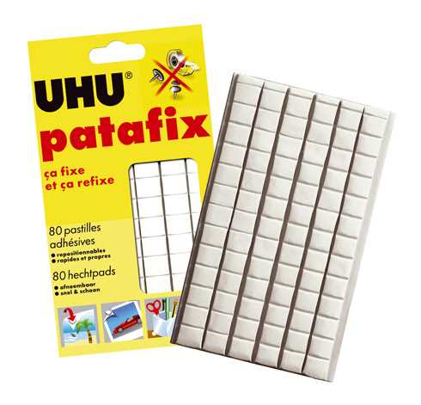

Diagonal cutter (DK: Skævbidder)
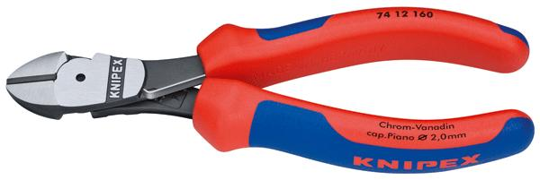
Any hardware store (see last page for tips on stores)

Plier (DK: Spidstang)
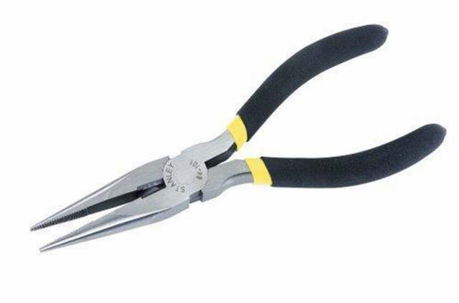
Any hardware store (see last page for tips on stores)

Screw driver set (both large and small)
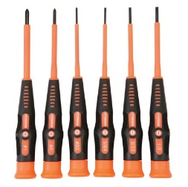
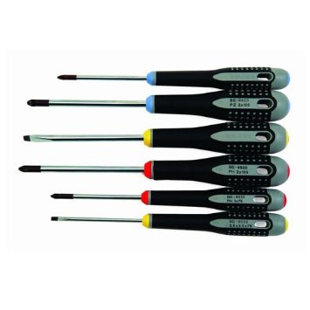
Any hardware store (see last page for tips on stores)

Measuring tape (DK: Målebånd)
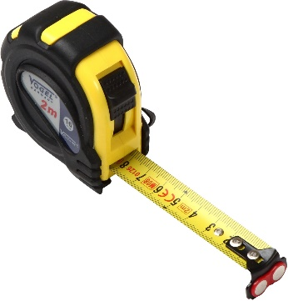
Any hardware store (see last page for tips on stores)

Jumper-wires
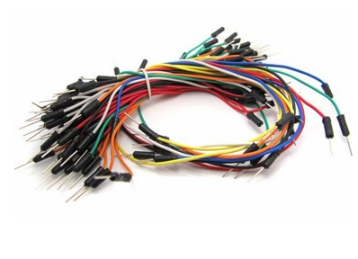
https://www.elextra.dk/main.aspx?page=article&artno=H30624

Nice-to-have

The following items can all be found in stores like Harald-Nyborg, Silvan, Bauhaus (Harlad-Nyborg is the cheapest option)

Wire stripper (for small wires)
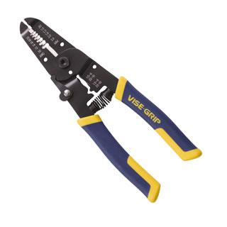
Any hardware store (see last page for tips on stores)

Alligator clip test leads
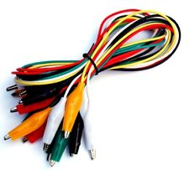
http://www.pc-elektronik.dk -> Search for “testledninger” (cheap)
https://www.conradelektronik.dk/Pr%f8veledning-s%e6t-VOLTCRAFT-KS-280%2f0%2e1-%5b-Krokodillen%e6b-Krokodillen%e6b%5d-0%2e28-m-Sort,-R%f8d,-Gul,-Gr%f8n,-Hvid.htm?websale8=conrad-dk&pi=108489&ci=SHOP_AREA_17627_1119025

Glue Gun
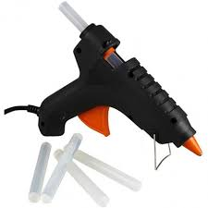

Utility Knife

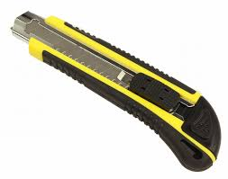
Can be found in Harald-Nyborg, Silvan or other hardware stores

Scissors
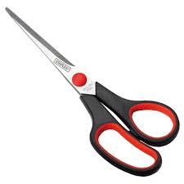

Cutting Ruler
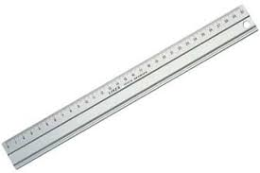
http://www.boesner.dk/skaerevaerktoj/skaerevaerktoj/underlag-linealer/skaere-lineal-af-metal

Cutting Mat
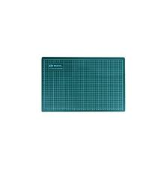
https://www.brondsholm.dk/hobbyknive-skraber/373-skaerer-underlag.html

Stores

Electronic stores:
- Elextra.dk (Has a shop here in Aalborg, Vesterbro 85)
- Electrozone.dk
- Let-elektronik.dk
- elektronik-lavpris.dk
- pc-elektronik.dk (terrible designed webpage but extremely cheap, see for example their alligator clip test leads (testledninger))
- Conradelektronik.dk

Hardware stores:
- Biltema and Harald-Nyborg (online store too) are extremely cheap and usually decent quality
  - Located in Skalborg / City Syd, 15 mins by bus)
- Silvan, Stark and XL-Byg are usually a bit better quality, but also more expensive
  - Located on the street Håndværkervej in Aalborg

