Bachelor in Art (Oplevelsesteknologi)
Respondents: 10 (8 complete, 2 partially completed)
Bachelors: 21
Responsrate: 48%

Do you expect to complete the programme/have you already completed the programme this summer?
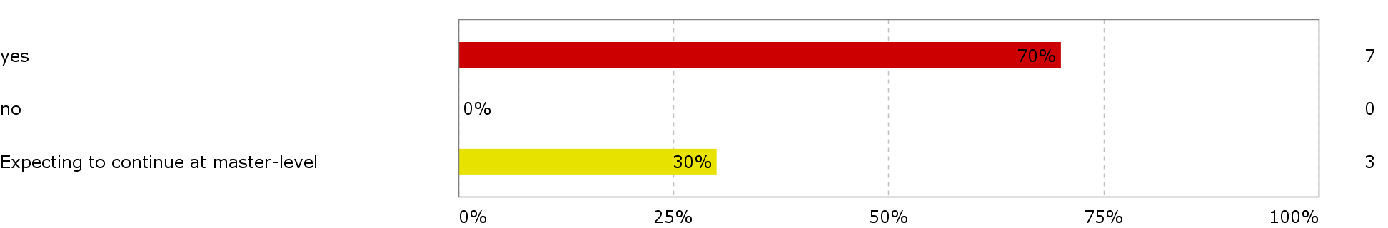

To what extent has the programme lived up to your expectations? (1 = to a very low degree, 2 = to a low degree, 3 = somewhat, 4 = to a large extent, 5 =very much so)
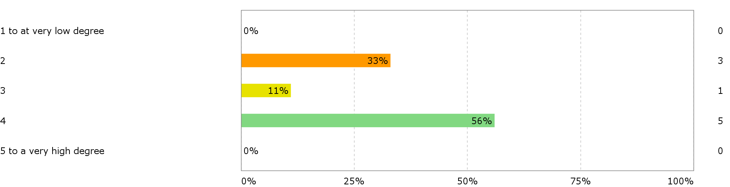

How do you assess the academic level? (1 = to a very low degree, 2 = to a low degree, 3 = somewhat, 4 = to a large extent, 5 = very much so)
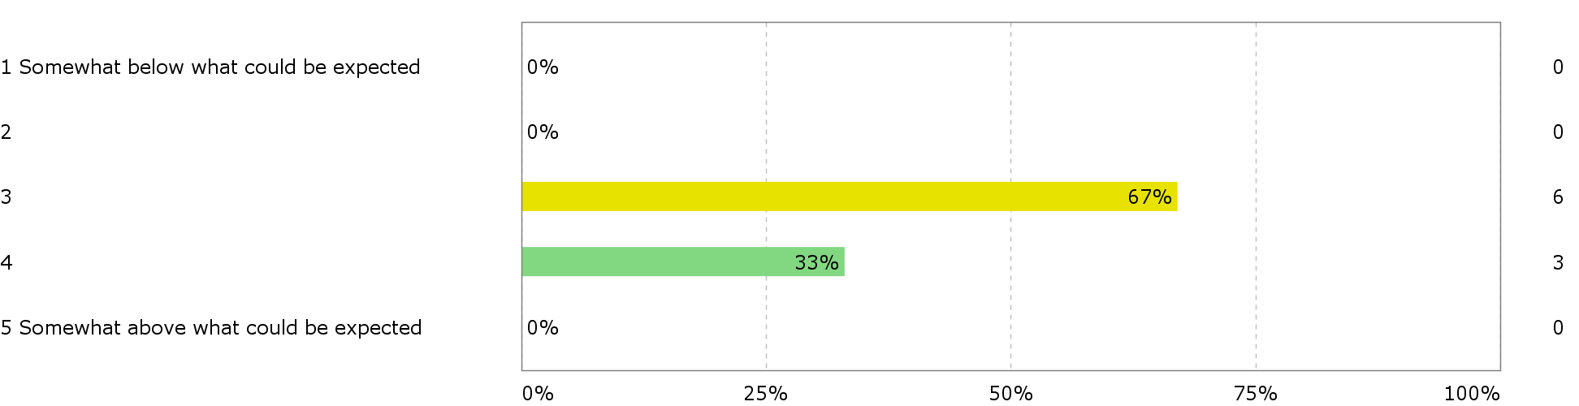

How do you assess the academic content? (1 = very unsatisfactory, 2 = unsatisfactory, 3 = neither satisfactory nor unsatisfactory, 4 = satisfactory, 5 = very satisfactory)
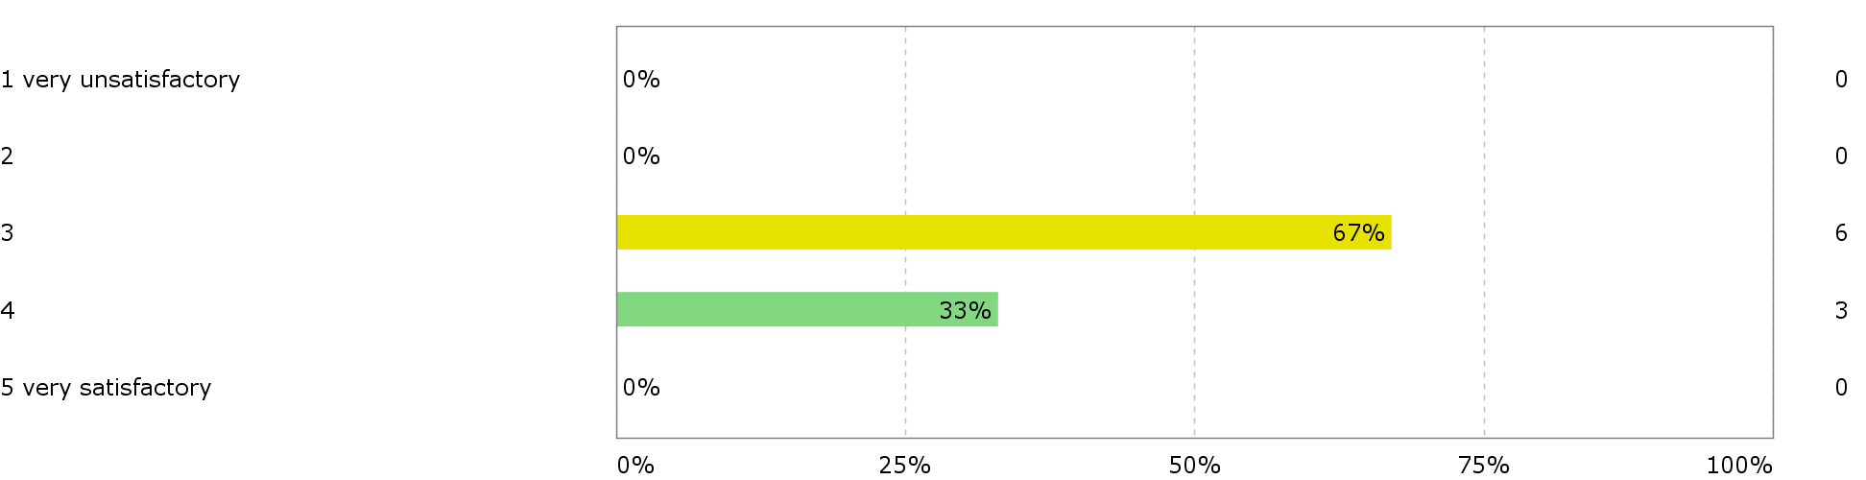

How do you assess the coherence of the programme, within semesters as well as between semesters? (1 = very poor, 2 = poor, 3 = neither good nor poor, 4 = good, 5 = very good)
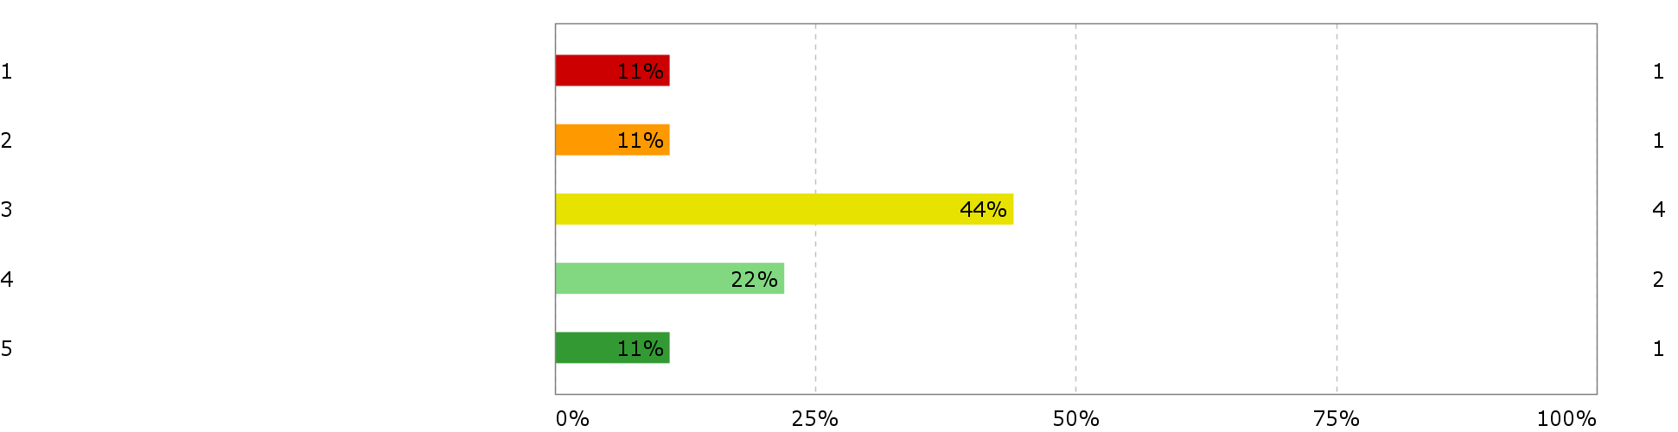

To what degree has the education given you the following competences (1= to a very low degree, 2= to a low degree, 3= somewhat 4= to a high degree 5= to a very high degree)

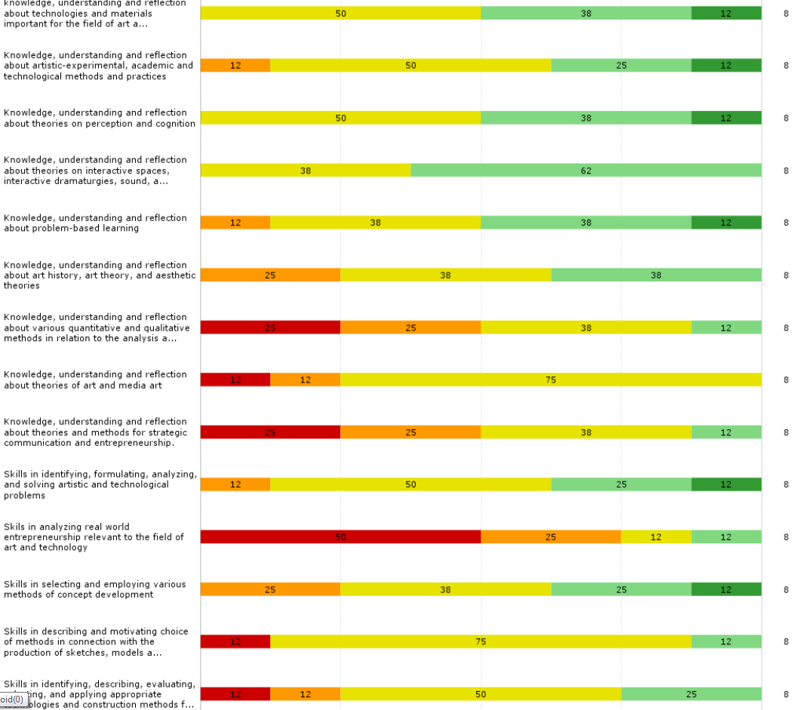

Continued

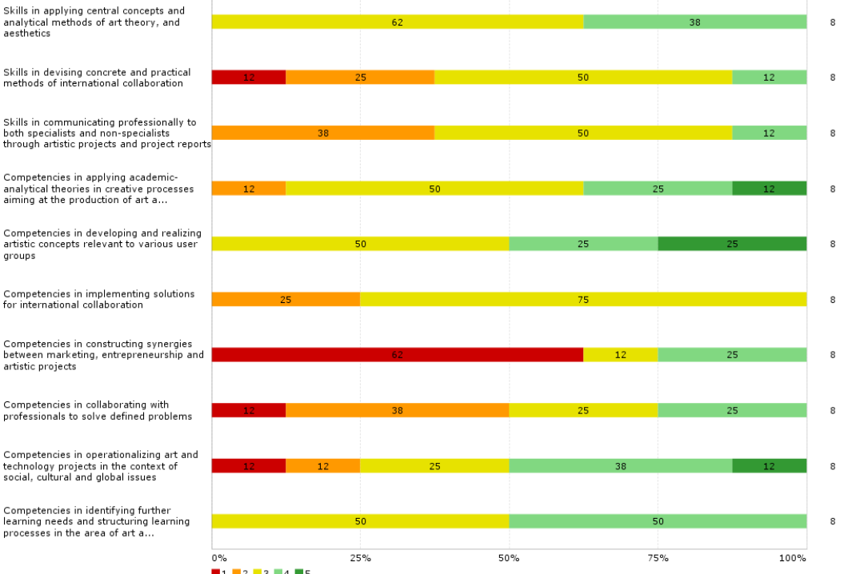

How do you evaluate you opportunity to influence the education content and profile (1= Very bad, 2= bad, 3= appropriate, 4= Good 5 = very Good)
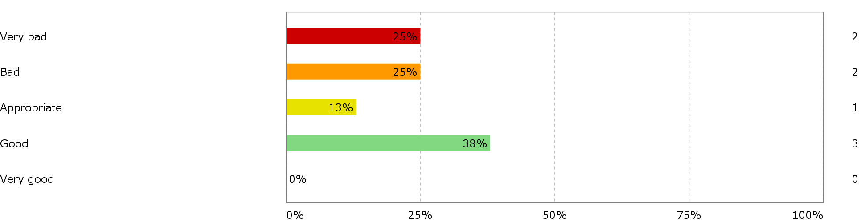

How do you evaluate your opportunities to influence the content and profile of your education ? (1= very poor, 2= poor, 3= appropriate, 4= good, 5= very good)
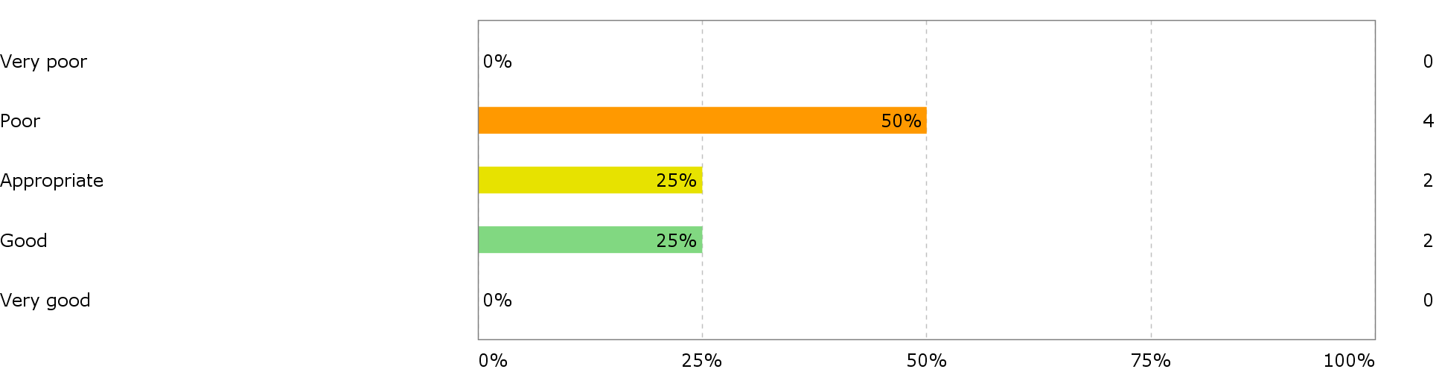

How has your study work load been? (1 = much too high very , 2 = too high, 3 = somewhat adequate, 4 = adequate , 5 = suitable)
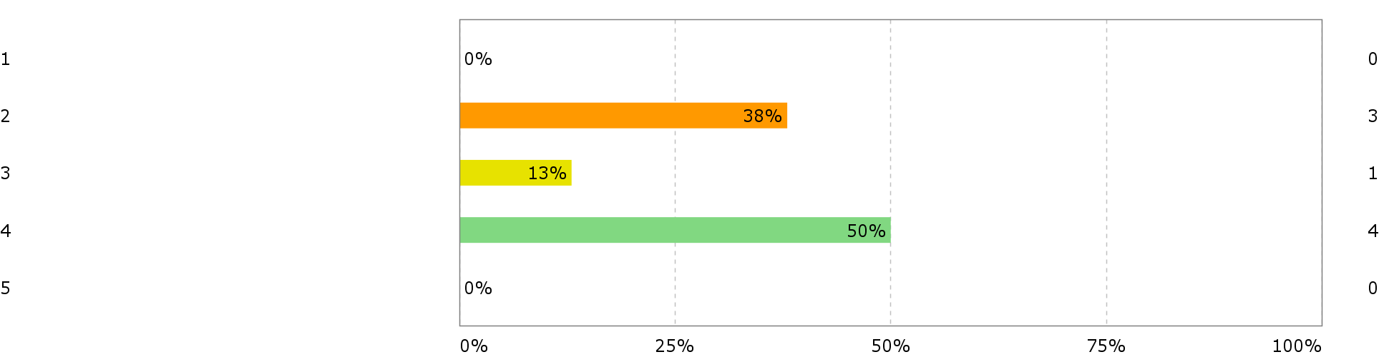

How do you assess the distribution of your study work load over the course of study? (1 = very irregular, 2 = irregular, 3 = neither regular nor irregular, 4 = regular, 5 = very regular)
